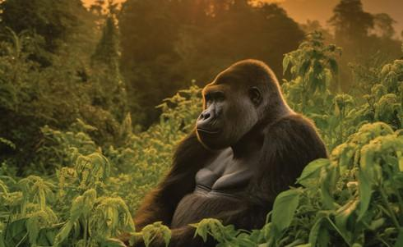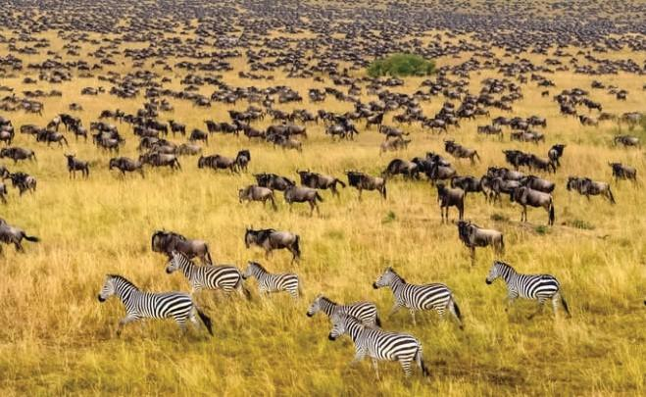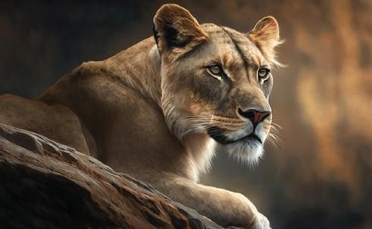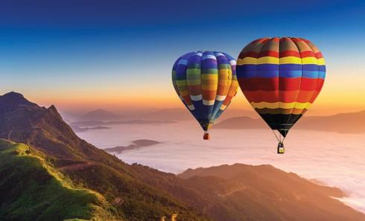

RWANDA AND UGANDA

RWANDA –UGANDA 10 DAYS

Rwanda, known as the Land of a Thousand Hills, is a refined and captivating destination in east-central Africa. With its rolling green landscapes, intimate wildlife encounters, and the vibrant capital of Kigali at its heart, Rwanda offers an exclusive yet accessible African experience.
Uganda is a hidden gem of natural beauty and adventure, from majestic mountains and rare wildlife to sweeping savannahs and powerful rivers. It delivers authentic, high-end safari experiences with exceptional value.
At Tilenga Safaris, we create bespoke journeys that combine comfort, elegance, and competitive pricing, ensuring unforgettable experiences without compromise. This time, we take you on an unforgettable journey through Rwanda and Uganda.

TRAVEL HIGHLIGHTS
- Genocide memorial visit
- Akagera National Park
- Game Viewing
- Boat ride on Lake Ihema
- Gorilla Tracking
- Golden Monkey Tracking
- Chimpanzee Tracking
- Game Drive for the Big Five
- Rhino tracking
- Boat cruise Safari on the Nile
- Cultural Experiences

DETAILED ITINERARY

DAY 1: ARRIVAL AND DRIVE TO AKAGERA NATIONAL PARK
Akagera National Park is home to the shy Oribi and to the elusive topi. The Highlands afford a breathtaking view across the undulating hills, rolling grassland to the extensive series of lakes, linked by papyrus swamps. Elephants, buffalo, giraffes, zebras, and waterbucks are some of the animals you will see in the game park roaming. It is their peaceful heaven.
On arrival in Kigali City, you will have breakfast, then a Kigali City tour, lunch, and right after be transferred to Akagera National Park for game viewing and later dinner.
Main Destination: Akagera National Park
Accommodation: 5★ Magashi Camp | 4★ Akagera Game Lodge | 3★ Ruzizi Tented Camp
Meals and drinks: Full Board

DAY 2: GAME DRIVE AND BOAT CRUISE ON LAKE IHEMA
You will start your day with an early morning game drive, then lunch, and a boat cruise on Lake Ihema.
Game drives in Akagera National Park are done in safari vehicles starting in the early morning in search of the leopards, hyenas, and the reintroduced lions. This is because the predators prefer to hunt at night or early morning and usually go into hiding as the heat from the sun increases.
The park is also home to over 500 bird species. As you take time to explore all the corners of this unique habitat and enjoy a boat ride on Lake Ihema.
Main Destination: Akagera National Park and Lake Ihema
Accommodation: 5★ Magashi Camp | 4★ Akagera Game Lodge | 3★ Ruzizi Tented Camp
Meals and drinks: Full Board

DAY 3: KIGALI GENOCIDE MEMORIAL VISIT AND TRANSFER TO UGANDA
After an early breakfast at the lodge, transfer to Kigali and then visit the Kigali Genocide Memorial. And in the afternoon, you will proceed to Bwindi Impenetrable National Park in Uganda via the Rwanda–Uganda border (Cyanika or Katuna, depending on your route). The drive is approximately 2 to 4 hours, including the border crossing.
A visit to the Kigali Genocide Memorial is a moving and educational experience that honors the victims of the 1994 Genocide against the Tutsi. It offers powerful historical insight and a space for reflection, helping visitors understand Rwanda’s journey toward reconciliation and renewal.
Main Destination: Bwindi Impenetrable National Park
Accommodation: 5★ Nkuringo Bwindi Gorilla Lodge | 4★ Mahogany Springs Lodge | 3★ Four Gorilla Lodge
Meals and drinks: Full Board

DAY 4: GORILLA TRACKING AND AN OPTIONAL AFTERNOON ACTIVITY
Gorilla treks begin at 8 AM every day with a briefing, after which groups of a maximum of eight tourists trek into the mysterious jungle. The trek can last anywhere from 1 hour to 5 hours, depending on where the gorillas will be on a specific day, and you will be led by expert rangers and an experienced team of advanced trackers.
Later in the afternoon, you will then head out for an activity at Ride 4 A woman.
A Ride for a Woman in Bwindi Impenetrable National Park offers simple but meaningful activities that connect visitors with the local community. You can take a village walk, join the women in singing and dancing, and learn basic skills like basket weaving or cooking traditional food. The experience is relaxed and personal, giving you time to hear real stories and understand how the project supports women in building better lives. It’s a genuine way to engage with the culture while directly supporting the community.

Main Destination: Bwindi Impenetrable National Park
Accommodation: 5★ Nkuringo Bwindi Gorilla Lodge | 4★ Mahogany springs Lodge | 3★ Ride 4 A woman
Meals and drinks: Full Board

DAY 5: TRANSFER TO QUEEN ELIZABETH NATIONAL PARK
After breakfast, you will transfer from Kisoro to Bwindi Impenetrable National Park. The journey takes approximately 5 to 6 hours, offering scenic views along the way.
Queen Elizabeth National Park (the second-largest park in Uganda) is named after the Late Queen Elizabeth II (RIP) and is popularly known for its Savannah grasslands and being home to the big cats, i.e., lions, leopards, etc., and Elephants.
You will have an afternoon/ evening game drive for the big four – Elephants, Lions, Leopard, and Buffaloes.

Main Destination: Queen Elizabeth National Park
Accommodation: 5★ Kyambura Gorge Lodge | 4★ Elephant Plains Lodge | 3★ Kikorongo Safari Lodge
Meals and drinks: Full Board

DAY 6: BOAT CRUISE SAFARI AND TRANSFER TO KIBALE NATIONAL PARK
The day begins with a boat cruise Safari on the Kazinga Channel is a highlight of the safari in Queen Elizabeth National Park, and it will reward you with wonderful sightings of Hippos, Crocodiles, Monitor Lizards, Elephants, Buffalo, and Antelopes, and by the water, trying to stay hydrated. And then return to the Lodge for Dinner and a night’s rest.
QENP is home to 618 bird species, which is the 6th highest diversity in the world and the highest in Africa, making it a perfect destination for Birding, in addition to 10 primate species like chimpanzees and 95 mammals, including the big 5.
An early lunch and afternoon transfer to Kibale Forest National Park.
After check-in, an optional activity is to visit the Bigodi community. The Bigodi community walk is a walk through one of the most scenic areas and habitats of bird and mammal species. A three-hour walk through the Bigodi swamp allows you to spot over 310 bird species, 5 different primates, and very beautiful flora.
The walk will take up to 2 to 3 hours, depending on the pace of the group. According to your interests, you will first visit a traditional healer who will happily share his knowledge about spirits, herbs, plants, and local medicines.
Main Destination: Kibale National Park
Accommodation: 5★ Kibale Lodge | 4★ Primates Lodge Kibale | 3★ Kibale Tourist Safari Lodge
Meals and drinks: Full Board

DAY 7: CHIMPANZEE TRACKING AND TRANSFER TO MURCHISON FALLS NATIONAL
Early morning Chimpanzee tracking and a scenic transfer to Murchison Falls National Park with a stopover at the Falls.

During tracking, you will be able to see other primates and wildlife like the red-tailed monkeys, black and white colobus monkeys, and a variety of bird species, among others.
While it can be challenging to follow the lead of these agile primates, the experience is thoroughly rewarding.
In the afternoon, you will continue your journey to Murchison Falls with a stopover for a simple hike to the Top of Murchison Falls, where the Nile squeezes through an 8-metre-wide gorge and plunges with a thunderous roar into the “Devil's Cauldron creating a trademark rainbow.
Murchison Falls National Park in Uganda is a spectacular wildlife destination, famous for its powerful waterfall on the Nile, abundant wildlife, and scenic savannah and riverine landscapes.

Main Destination: Murchison Falls National Park
Accommodation: 5★ Nile Safari Lodge | 4★ Entiko Safari Lodge | 3★ Tilenga Safari Lodge
Meals and drinks: Full Board

DAY 8: GAME DRIVE AND BOAT CRUISE ON THE NILE

An early morning game drive; while on the game drive, expect to see Elephants, Giraffes, Lions, Warthogs, Uganda Kobs, Buffaloes, Waterbucks, and some unique bird species in the wild. An early game drive to catch all animals before they go out to feed/hunt.

This activity takes between 3 and 4 hours, depending on how satisfied you are with your sighting. You will view elephants, lions, giraffes, leopards, buffaloes, Kobs, etc., then return to the Lodge for lunch.

In the afternoon, go for a launch cruise on the Nile to the launch/bottom of the mighty Murchison Falls, 10 meters away from the Devil’s Cauldron. Along the banks of the Nile, you will come up close to Hippo Schools, large crocodiles, Elephants cooling off by the shores of the Nile, waterbucks, and some birds, e.g., cormorants and bee-eaters, among others.

The launch cruise along the Nile will give you an exciting panoramic view of the bottom of Murchison Falls.

Main Destination: Murchison Falls National Park
Accommodation: 5★ Nile Safari Lodge | 4★ Entiko Safari Lodge | 3★ Tilenga Safari Lodge
Meals and drinks: Full Board

DAY 9: RHINO TRACKING

Breakfast and early morning transfer to Ziwa Rhino Sanctuary, where you will spend the night.

Rhino tracking at Ziwa Rhino Sanctuary is a guided on-foot experience where visitors follow trained rangers to observe white rhinos in their natural habitat. The activity involves walking through the sanctuary while learning about rhino behavior, conservation efforts, and safety measures, offering a close yet controlled encounter with these animals while supporting their protection.

Main Destination: Ziwa Rhino Sanctuary
Accommodation: Ziwa Rhino Sanctuary
Meals and drinks: Full Board

DAY 10: DEPARTURE

This is the last day of your trip. After having breakfast, you will start your journey to Kampala.
The drive to Entebbe International Airport takes approximately 5 to 7 hours, offering one last chance to soak in Uganda’s scenic landscapes before you board your departure flight home, carrying unforgettable memories of your safari adventure.
Main Destination: Entebbe International Airport
Meals and drinks: Full Board

END OF TRIP

TOUR COSTS – QUOTED IN USD
NO OF PAX | 2 | 3 | 4 | 5 | 6 | SGL
COST PER PERSON  MIDRANGAE | 7306 | 6591 | 6233 | 6019 | 5876 | 2150

INCLUSIONS
- All Park fees
- All activities
- All accommodation as per the options chosen
- A professional driver/guide
- All transportation in a safari 4 X 4 vehicle with a pop-up roof
- All Taxes/VAT
- Round-trip airport transfer
- Meals (As specified in the day-by-day section)
- Complementary bottle of water per day while on safari
- An English / language professional guide

EXCLUSIONS
  - Domestic and International flights (From/to home)
  - Visas
  - Additional accommodation before and at the end of the tour
  - Tips



  - Personal items (Souvenirs, travel insurance, etc.)

  - Government-imposed increase of taxes and/or park fees

.

